Android Penetration Testing

Lab Setup: -

1. Virtual BOX

* <https://www.virtualbox.org/>

1. Santoku OS

* <https://santoku-linux.com/>

1. Geny Motion

* <https://genymotion.com/>
* Virtual Box
* https://www.virtualbox.org/
* First Download VirtualBox
* Normally install like other application we install

Santoku OS Installation

1. First Download Santoku OS

<https://santoku-linux.com/>

1. Then Open virtual box which we installed –
   * + - Then click new-

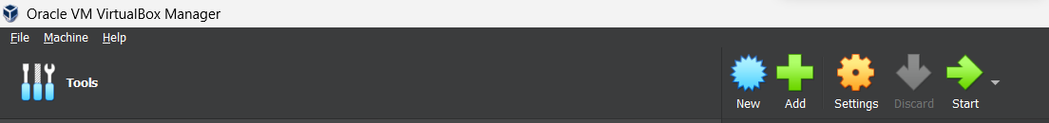

* Then type name and choose machine folder where do you want install, select OS type and OS version and then click next.

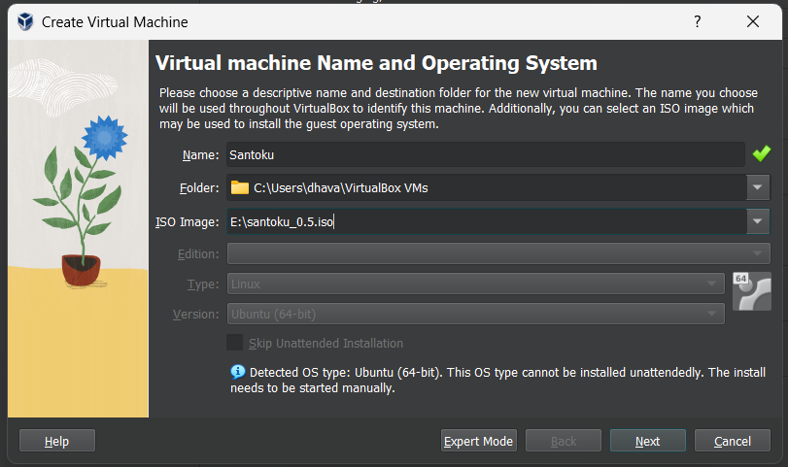

* Then select memory size

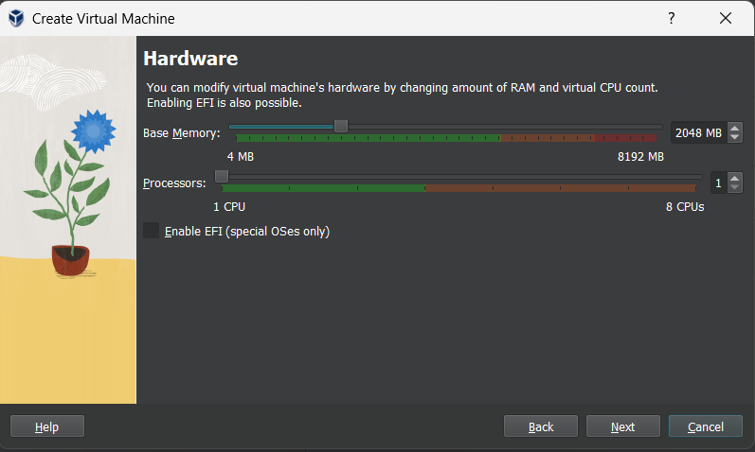

* Select a hard disk space

